LAB-6:STATIC ROUTING

Static routing is a type of network routing technique. Static routing is not a routing protocol; instead, it is the manual configuration and selection of a network route, usually managed by the network administrator. It is employed in scenarios where the network parameters and environment are expected to remain constant

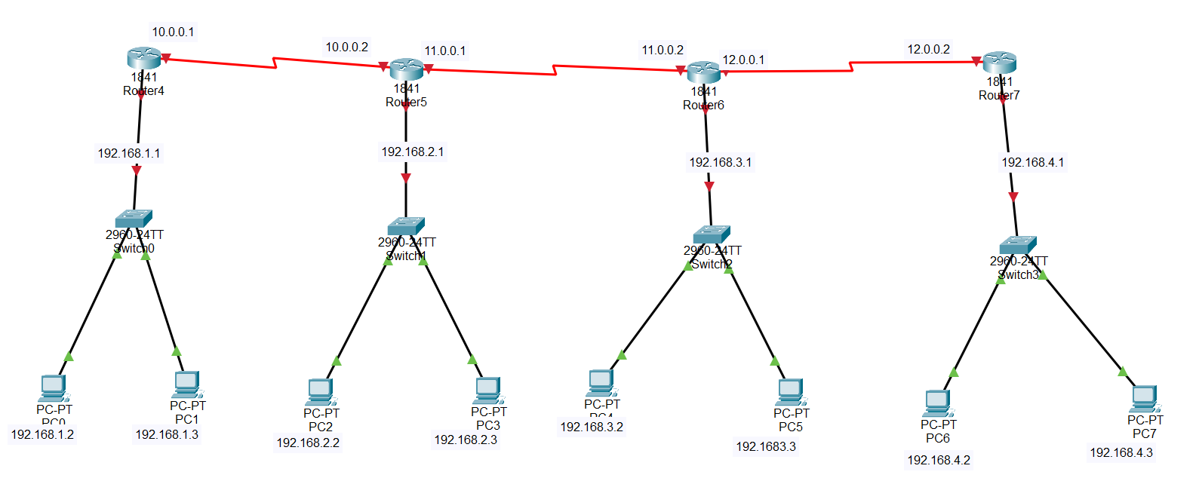

# Router 0 IP Configurations

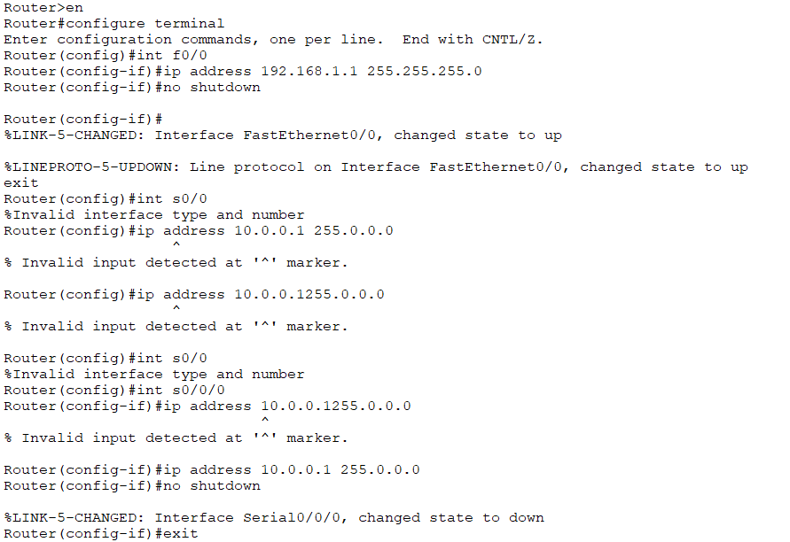

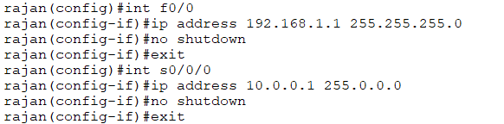

# Router 1 IP configurations

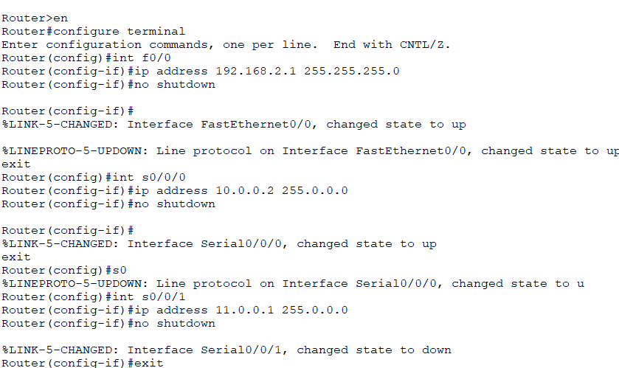

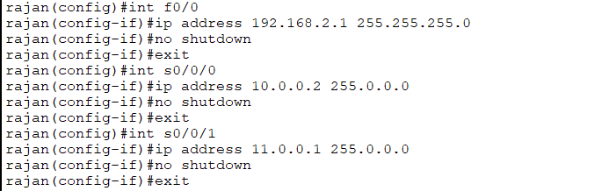

# Router 2 IP configurations

# 

# 

**Router 3 IP configurations**

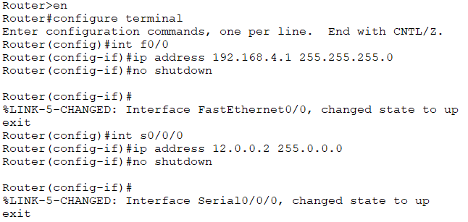

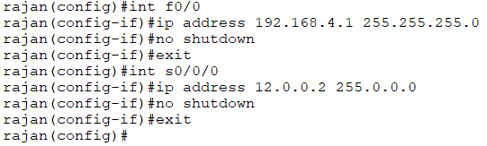

**Now configuring the static routes into the router**

**Router 0**

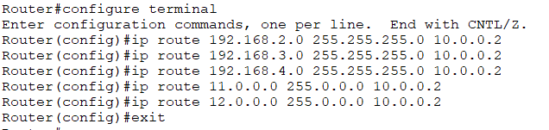

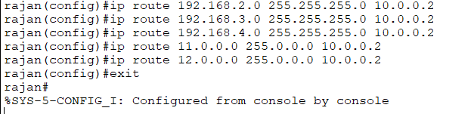

# ROUTER 1

# 

# 

# ROUTER 2

# 

# 

# ROUTER 3

# 

# 

**PING**

